Practicle NO: 4
Title - Write a program for implementing security measures in an IIoT system.

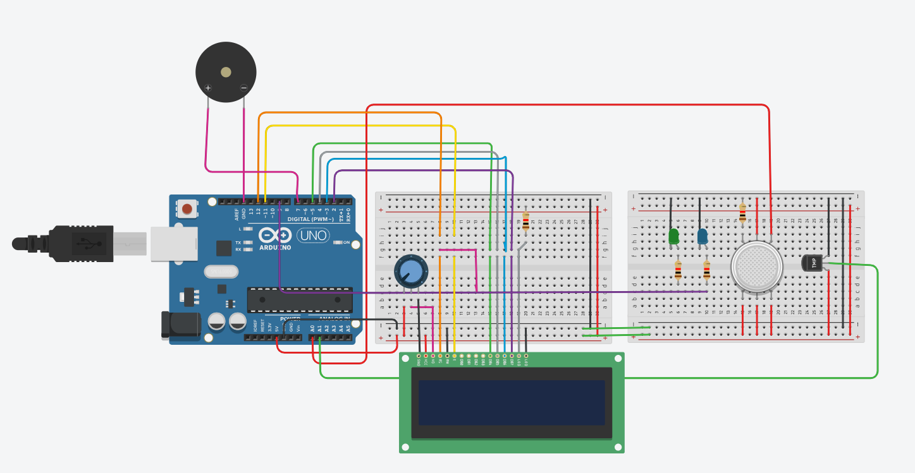
#include <LiquidCrystal.h>
// Initialize the LCD with the pin numbers
LiquidCrystal lcd(12, 11, 5, 4, 3, 2);
int V_GasSen = 0;
int V_TempSens = 0;
void setup() {
pinMode(A0, INPUT); // Gas sensor pin
pinMode(A1, INPUT); // Temperature sensor pin
pinMode(7, OUTPUT); // Buzzer pin
pinMode(9, OUTPUT); // LED for gas detection
pinMode(12, OUTPUT); // LED for temperature warning
lcd.begin(16, 2); // Initialize the LCD with 16 columns and 2 rows
}
void loop() {
// Read gas sensor value
V_GasSen = analogRead(A0);
// Read temperature sensor value and calculate temperature
V_TempSens = -40 + 0.488155 * (analogRead(A1) - 20);
// Display temperature and gas status on the LCD
lcd.clear(); // Clear the LCD
lcd.setCursor(0, 0); // Set cursor to the first row
lcd.print("Temperature: "); // Print temperature label
lcd.print(V_TempSens); // Print temperature value
lcd.print(" C"); // Print temperature unit
lcd.setCursor(0, 1); // Set cursor to the second row
lcd.print("Gas: "); // Print gas label
lcd.print(V_GasSen); // Print gas sensor value
// Check for alerts
if (V_GasSen >= 250) {
tone(7, 523, 1000); // Play tone if gas is detected
digitalWrite(9, HIGH); // Turn on the gas detection LED
lcd.clear();
lcd.setCursor(0, 0);
lcd.print("ALERT: Gas Detected");
} else {
digitalWrite(9, LOW); // Turn off the gas detection LED
}
if (V_TempSens >= 70) {
tone(7, 523, 1000); // Play tone if temperature exceeds the threshold
digitalWrite(12, HIGH); // Turn on the temperature warning LED
lcd.clear();
lcd.setCursor(0, 0);
lcd.print("ALERT: Temp High");
} else {
digitalWrite(12, LOW); // Turn off the temperature warning LED
}
delay(1000); // Delay for one second
}

